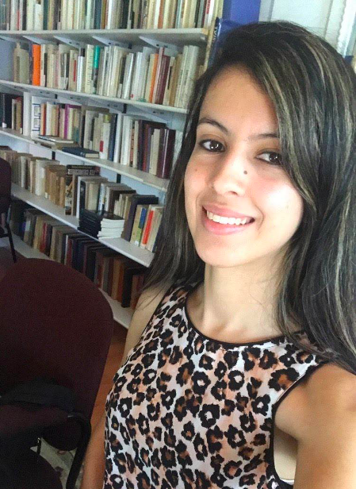 Mariam Shea

Mariam was born and raised in the bilingual country of Morocco where French is one of the native languages. She moved to the United States of America to pursue her passion of teaching languages. She attended Bridgewater State University where she earned her Master’s degree in teaching. She is licensed to teach French and English and has worked with different levels of proficiency and different group ages both in person and remote. In addition, she is skilled at developing lessons and curriculum units.
Mariam has always been fascinated by language acquisition and the beauty of languages. She enjoys sharing her knowledge with others. She has experience learning languages both as a child and an adult and believes that it is never too late to learn a new language. She understands how to help students transfer their knowledge from their first languages to the target language making it easier for them to learn.
Mariam knows that learning a new language can seem like a big challenge but she believes one of the keys to success is to immerse yourself in it and be willing to take risks because making mistakes is just part of the learning process.
In her free time, Mariam loves to travel to explore new areas and cultures. She also loves to play board games. She has two ragdoll cats: Allie and Dexter.

