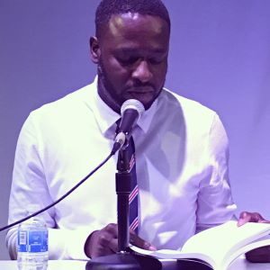 Fred Lafortune

Fred Lafortune was born in Haiti. After travelling to Paris in 2007, he moved to the U.S in 2009. He is the author of several books, including En nulle autre, Silex, and An n al Lazil, a poetry collection written in Haitian Creole for which he received the Dominique Batraville Prize in 2017. In 2018, Fred received the Best Poet of the Year Award by the Haitian Academy Award. Fred is also the director of a collection of poetry called “L’immortel” at JEBCA Editions in Boston. His poems have been published in several anthologies, including the “Anthologie de Poésie Haïtienne Contemporaine,” published in Paris by Édition du Seuil – Collection Points. Additionally, several of his poems have been published in various literary magazines and journals, as well as online publications.
Fred currently lives in Rhode Island with his wife Joanne and their two children Grace and Isaac. He has been teaching Haitian Creole at the Alliance Française of Providence since 2016 and is currently a PhD student in French Language & Literature at Boston University

