ITALIAN Faculty Member
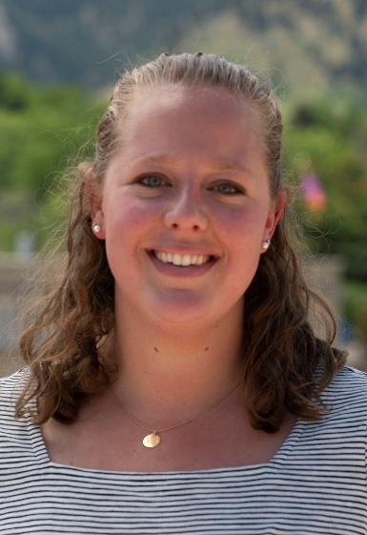
Julia Millon
A little background….I have been fluent in Italian since childhood and have studied Italian language and literature through high school. I lived in Viterbo, Italy during this time and have traveled to see family on frequent returns to Rome.
I majored in Italian at the University of Colorado Boulder, where I graduated summa cum laude and With Distinction. While attending CU Boulder, I was also fortunate enough to have my honors thesis published, which focused on women in Fascist Italy and translation theory. Additionally, I had the honor of being the first to translate specific literary works to English by author Carola Prosperi.
Since graduation in 2013, I have held multiple tutoring and teaching positions, both at the high school and college levels, as can be seen in my resume.
Education: MA Administration. Northwestern University, Evanston, IL Mar 2018 (GPA 3.89) BA in Italian. University of Colorado at Boulder, Boulder, CO May 2013, summa cum laude, With Distinction (GPA 3.85)
Teaching and Tutoring Experience Northwestern University, Evanston, IL April 2019 – Present Teaching master's level classes remotely. Visiting Lecturer Connecticut College, New London, CT Nov 2019 – Mar 2020 Evanston Township High School, Evanston, IL Mar 2016 – Jan 2018 Italian and Spanish Tutor
Professional Experience Harvard T.H. Chan School of Public Health, Boston, Nov 2020 – Present Assistant Director of Development Natural Hazards Center, University of Colorado Boulder, Boulder, CO Apr 2020 – Present Translator Translate English language research documents, forms, and webpages to Italian and Spanish for the National Science Foundation- focusing on COVID-19 Connecticut College, New London, CT Jul 2019 – Nov 2020 -Leadership Annual Gift Officer Northwestern University, Evanston, IL Jan 2018 – Jun 2019 Program Coordinator, Alumni Relations and Development Northwestern University, Evanston, IL Dec 2016 – Jan 2018 Client Services Specialist, Athletics Evanston Township High School, Evanston, IL May 2016 – Nov 2016 Assistant Director, Alumni and Donor Relations
Internship Experience Boston Bruins Foundation, Boston, MA May 2014 – Aug 2014 Foundation Intern. Assisted Foundation staff with the organization and fulfillment of the 2014 grant meeting. Facilitated the distribution of over $500,000 to recipients by processing grant paperwork, and organized site visits to grant recipients in the Greater Boston Area Planned and executed major fundraising events, and solicited local businesses for donations and support. Coordinated all monetary and memorabilia donations internationally, organized player and mascot appearances. Worked closely with Boston Bruins Pan Mass Challenge (PMC) and Boston Marathon teams to facilitate fundraising and day-of-event activities United States Agency for International Development, (Remote) Sept 2012 – May 2013 Intern – Development Innovation Ventures
Consulate General of Italy, Boston Intern to the Education Director Developed curricula for Boston Public School System Italian teachers Translated teaching materials from English to Italian and Italian to English for BPS Italian teachers
Department of State, (Remote) Foreign Language Intern: Worked to create, write, produce, and film materials for Italian nationals on American history and culture via social media
Languages Fluent in Italian, Spanish and proficient in French and beginner in German

